SUPREME COURT OF THE STATE OF NEBRASKA
CERTIFICATE OF AUTHORITY

This registration certificate is hereby issued by the Nebraska Supreme Court to Exact Firm Name.
______________________________________________________ _____________
(Exact Firm Name)
for the practice of law as a domestic professional organization in the form of a limited liability partnership.

The Clerk of the Supreme Court of the State of Nebraska does hereby certify that the partners of the above-named limited liability partnership are those person named by the limited liability partnership in its application for this certificate and set forth in the records maintained by the Clerk of the Nebraska Supreme Court, that one or more of the partners of the above-named limited liability partnership are duly licensed to practice law in the State of Nebraska, that all such partners are licensed to practice law either in this State or in one or more other states, territories of the United States, or the District of Columbia, and that the above-named limited liability partnership complies with the Limited Liability Partnership provisions of the Uniform Partnership Act of 1998 and the canons, rules, and regulations imposed by the Nebraska Supreme Court for limited liability professional organizations.
ATTACH SEPARATE LIST OF PARTNERS
The professional employees of said limited liability partnership are those persons named by the limited liability partnership in its application for this certificate and set forth in the records maintained by the Clerk of the Nebraska Supreme Court and are hereby certified as duly licensed to practice law in the State of Nebraska or in one or more other states, territories of the United States, or the District of Columbia.
ATTACH SEPARATE LIST OF ASSOCIATE ATTORNEYS
The principal place of business and chief executive office of the above-named limited liability partnership is Address, City, State, ZIP.
_____________________________________________.
(Address, City, State, Zip)
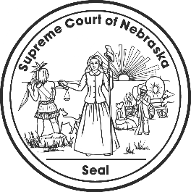
IN TESTIMONY WHEREOF, I have hereunto set my hand and caused to be affixed
the Seal of the Court, in the City of Lincoln, this __________________.

__________________________________________________
Clerk, Supreme Court of Nebraska

This certificate expires one year from the date of issuance.

